EXP NO 4: CREATE A SIMPLE CLOUD SOFTWARE APPLICATION FOR CAR BOOKING RESERVATION SYSTEM USING ANY CLOUD SERVICE PROVIDER TO DEMONSTRATE SAAS.

AIM: To Create a simple cloud software application for Car Booking Reservation System using any Cloud Service Provider to demonstrate SaaS.

PROCEDURE:
Step1: Go To Zoho.Com.
Step 2: Log Into The Zoho.Com.
Step 3: Select One Application Step.
Step4: Enter Application Name As Car Booking Reservation System.
Step 5: Created New Application As Car Booking Reservation System.
Step 6: Select One Form
Step 7: The Software Has Been Created.

IMPLEMENTATION:
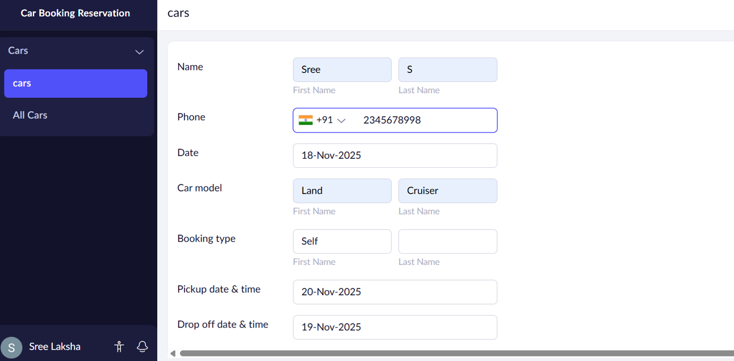
OUTPUT:
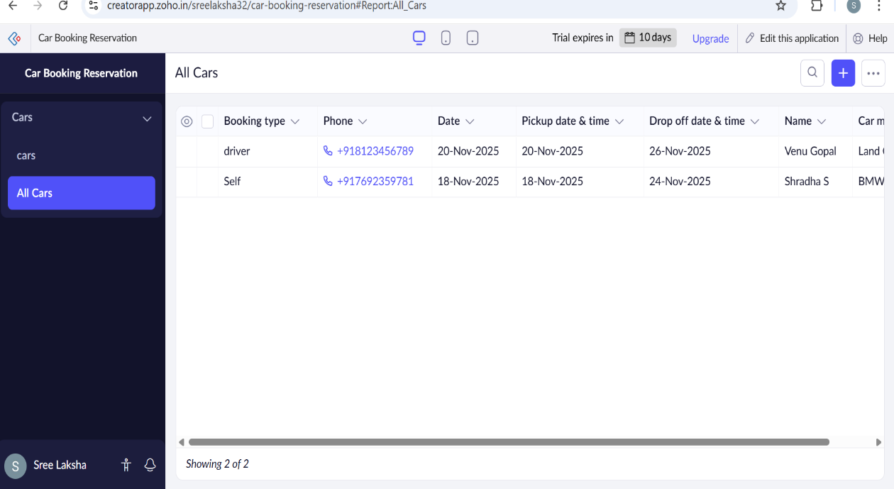

RESULT:
Thus a simple cloud software application for Car Booking Reservation System using any Cloud Service Provider to demonstrate SaaS was done successfully.

